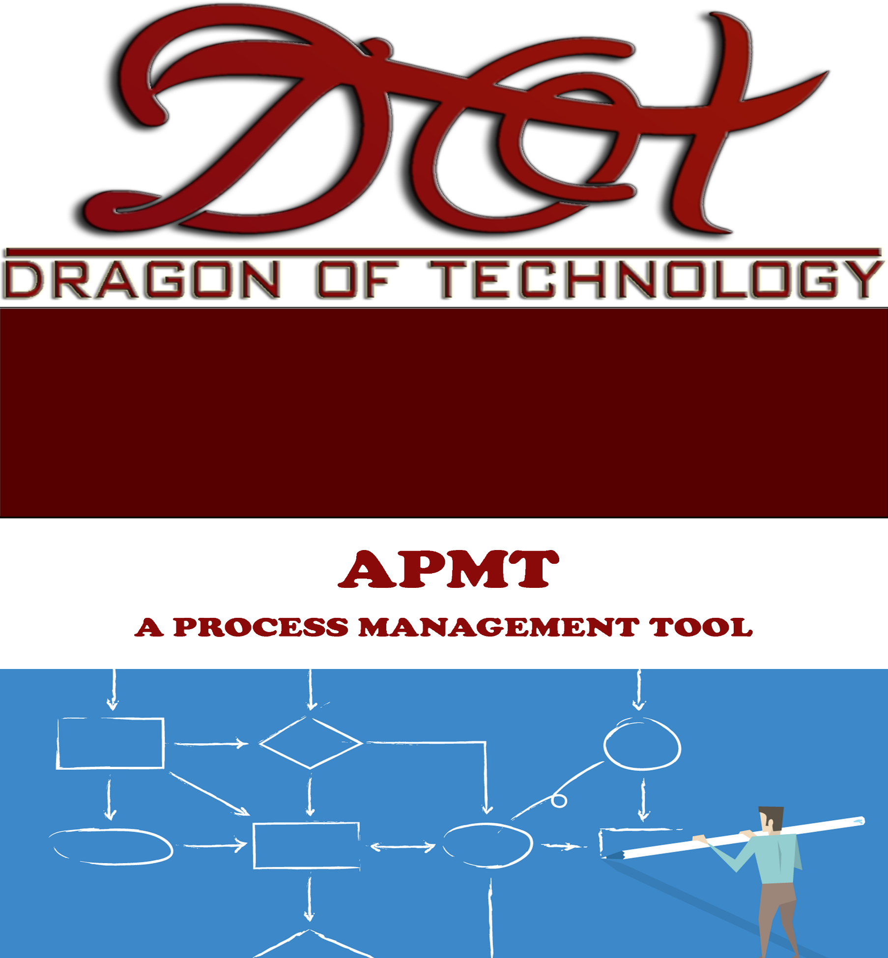

COMMUNICATION MANAGEMENT

PLAN

# Document Audience

This section contains a list of target audiences.

|  |  |
| --- | --- |
| **Target Audience** | **Recommended Section** |
| Project Mentors | All of Document |
| Product Owner | Section 2, 3 & 4.4 |
| Development Team | All of Document |

# Version History

|  |  |  |  |
| --- | --- | --- | --- |
| **Version** | **Release** | **Author** | **Content** |
| 1.0 | October 4th 2016 | Hung Mai | Create document |
|  |  |  |  |

**Table of Contents**

Document Audience 1

Version History 1

**1.** **Introduction** 4

**1.1.** **Purpose** 4

**1.2.** **Scope** 4

**2.1.** **Product Owner** 4

**2.2.** **Project Stakeholders** 4

**2.3.** **Development Team** 4

**3.** **Detailed Plan** 5

**3.1.** **Communication Plan** 5

**3.2.** **Development Team Contact Together** 5

**3.3.** **Mentors and Development Team Contact Together** 6

**3.4.** **Product Owner and Development Team Contact Together** 6

**4.** **Meeting Plan** 7

**4.1.** **Scrum Meetings** 7

**4.2.** **Internal Development Team Meetings** 7

**4.3.** **Mentors Meeting (Weekly Report Meeting)** 8

**4.4.** **Sprint Review Meeting** 8

**4.5.** **Product Owner Meeting** 8

**5.** **Communication Management Constraints** 8

**6.** **Roles and Responsibilities** 9

**7.** **Communication Matrix** 9

**LIST OF TABLES**

Table 1. Configuration Items 5

Table 3. Document standard 7

Table 4. Prescribed for excel documents 7

Table 5. Repository 7

Table 6. Tool for team management, track bugs, assign task 8

Table 7. Folder organization 8

Table 8. Artifact life cycle 9

Table 9. Glossary 10

# **Introduction**

## **Purpose**

* Captured how to manage communications throughout the project life cycle.
* Knowing all Stakeholders in Capstone Project.
* What kind of the information can get from another Stakeholders?
* What get decided, method, frequency?

## **Scope**

The Communication Plan identifies the procedures used to manage communication for the Capstone Project. The plan focuses on formal communication elements. Other communication channels exist on informal levels and enhance those discussed within this plan. This plan is not intended to limit, but to enhance communication practices. Open, ongoing communication between stakeholders is critical to the success of the Capstone Project.

1. **Stakeholders Information**

This section contains the contact information of Capstone Project stakeholders.

## **Product Owner**

Email: [nhquoccm](mailto:vinapool@gmail.com)u@gmail.com

## **Project Stakeholders**

|  |  |  |  |
| --- | --- | --- | --- |
| **No.** | **Stakeholders** | **Position** | **Contact Information** |
| 1 | Nguyen Huu Quoc (Mr.Quoc) | Product Owner of AQ Tech | Email: nhquoccmu@gmail.com |
| 2 | Pham Ngoc Duy (Mr.Duy) | Project Mentor | Email: [phamngocduy@vanlanguni.edu.vn](mailto:phamngocduy@vanlanguni.edu.vn) |

*Table 1: Project Stakeholders Contact Information*

## **Development Team**

|  |  |  |
| --- | --- | --- |
| **No.** | **Members** | **Contact Information** |
| 1 | Le Cong Thang | Email: [lecongthang454@gmail.com](mailto:lecongthang454@gmail.com)  Phone Number: 01268350179 |
| 2 | Mai Phuoc Hung | Email: [maiphuochung24@gmail.com](mailto:maiphuochung24@gmail.com)  Phone Number: 01258888389 |
| 3 | Du Kim Quang | Email: [kimquang1995@gmail.com](mailto:kimquang1995@gmail.com)  Phone Number: 01222962226 |
| 4 | Nguyen Trong Nghia | Email: [nghianguyent133981@gmail.com](mailto:nghianguyent133981@gmail.com)  Phone Number: 0906616769 |
| 5 | Cu Minh Luan | Email: [cuminhluan1995@gmail.com](mailto:cuminhluan1995@gmail.com)  Phone Number: 01682777564 |
| 6 | Lê Minh Quan | Email: [quanminhle199x@gmail.com](mailto:quanminhle199x@gmail.com)  Phone Number: 01643953889 |
| 7 | Luu Quang Minh | Email: [luuquangminh1331@gmail.com](mailto:luuquangminh1331@gmail.com) Phone Number: 0963799503 |

*Table 2: Team Members Contact Information*

# **Detailed Plan**

## **Communication Plan**

This section will describe the methods which can be used in three cases of communicate:

* Development Team contact together.
* Mentor and Development Team contact together.
* Product Owner and Development Team contact together.

There are 4 methods to Development Team and Product Owner / Mentor contact together:

* **By Email:** is the main communication channel for everyone reports, discuss issues, which related to the project.
* **By Trello** : is the internal communication channel to manage the work in Development Team.
* **By Slack**: is a communication channel for Product Owner and Development Team contact together to discuss issues related to the product.
* **By Phone**: is a method of communication between stakeholders as quickly as possible to solve problems related to work schedules or meetings.

When there have some unexpected personal problems, member must contact Scrum Master as soon as possible to resolve.

## **Development Team Contact Together**

|  |  |  |
| --- | --- | --- |
| **No.** | **Communication Methods** | **Description** |
| 1 | Email | Every member check email regularly to receive assigned tasks, information on works and reply as soon as possible.  At the end of the day, Development Team send work report, which they completed in the day for Scrum Master. |
| 2 | Slack, Trello, Github | The Development Team provided an account to access the Slack. This is used to manage the group's activities, including activities such as scheduling, product backlog, user’s story, expenses, issues tracking… |
| 3 | Phone | The Development Team can use Phone to notify the important meetings, absent permission, support issues related to the Capstone Project as quickly as possible. |

*Table 3: Development Team Contact Together Description*

## **Mentors and Development Team Contact Together**

|  |  |  |
| --- | --- | --- |
| **No.** | **Communication Methods** | **Description** |
| 1 | Email | The Development Team send weekly report, meeting minutes after each Mentors Meeting and Product Owner Meeting; or request assistance of the Mentors to solve the team problems via Email.  The Mentors feedback and comment for Development Team the issues related to the Project.  The content of the Email must be transparent, clearly and publicity to all team members. |
| 2 | Phone | If the Development Team have an urgent problems, which don’t solve by Email then they can use Phone to contact with Mentors. |

*Table 4: Mentors and Development Team Contact Together Description*

## **Product Owner and Development Team Contact Together**

|  |  |  |
| --- | --- | --- |
| **No.** | **Communication Methods** | **Description** |
| 1 | Email | The Development Team send meeting minutes after each Product Owner Meeting; or request assistance of Product Owner to solve the problems related to the product via Email. After the Product Owner feedbacks and comments for Development Team.  The content of the Email must be transparent, clearly and publicity to all team members. |
| 2 | Phone | Product Owner and Development Team use Phone to set up Product Owner Meetings. If the Development Team have an urgent problems, which don’t solve by Email then they can use Phone to contact with Product Owner. |
| 3 | Slack | The Development Team using Slack to contact with Product Owner support issues, get feedbacks related to product development. |

*Table 5: Product Owner and Development Team Contact Together Description*

# **Meeting Plan**

This section will describe the meeting plan with stakeholders.

## **Scrum Meetings**

|  |  |  |  |
| --- | --- | --- | --- |
| Item | Stakeholders | Frequency | Description |
| Weekly Scrum Meeting | Development Team | * Monday, From 13:00 AM to 14:30 PM * Tuesday, From 8:00 AM to 17:00 PM * Saturday, From 10:30 AM to 17:00 PM | Reference:  Planning / Process Guideline |
| Weekly Report Meeting | Development Team  Mentors | Weekly on Tuesday  at 13:00 | Project Schedule  Project Summary  Risks / Issues |
| Sprint Planning Meeting | Development Team | Start of Sprint  at 09:00 | Reference:  Planning / Process Guideline |
| Sprint Review Meeting | Development Team  Product Owner | End of Sprint  Un-scheduled | Reference:  Planning / Process Guideline |

*Table 6: General – Scrum Meetings Table*

## **Internal Development Team Meetings**

Development Team will have # team meetings a week on to working, solve the problems, which happened in Team.

**Meeting content:**

* List all difficult problems when working on projects and brainstorm to find their solutions.
* Give ideas how to complete the work and improve work performance.
* Work in pairs or small groups that team members can work together and help others.
* Support and provide training for the lack of knowledge of members.
* Give comments on members who do not have earnest working attitude.
* Check team’s work progress and time, schedule of the project if they fit the project. If not, discuss with team to modify the plan appropriately (Responsible: Project Manager).

## **Mentors Meeting (Weekly Report Meeting)**

|  |  |  |  |  |
| --- | --- | --- | --- | --- |
| **No.** | **Day** | **Time** | **Place** | **Content** |
| 1 | Monday | 13:00 | 701C Room | Report project progress |

*Table 7: Mentors Meeting*

## **Sprint Review Meeting**

|  |  |  |  |  |
| --- | --- | --- | --- | --- |
| **No.** | **Day** | **Time** | **Place** | **Content** |
| 1 | *<The end of every Sprint>* | Not fixed | AQ Tech | Validate requirement and release product. |

*Table 8: Sprint Review Meeting*

## **Product Owner Meeting**

|  |  |  |  |  |
| --- | --- | --- | --- | --- |
| **No.** | **Day** | **Time** | **Place** | **Content** |
| 1 | *<Un-schedule>* | Not fixed | AQ Tech | Get requirement and feedback. |

*Table 9: Product Owner Meeting*

# **Communication Management Constraints**

* All project communication activities will occur within the project’s approved budget, schedule, and resource allocations
* Communication activities will occur in accordance with the frequencies detailed in the Communication Matrix in order to ensure the project adheres to schedule constraints. Any deviation of these timelines may result in excessive costs or schedule delays and must be approved by the project sponsor.

# **Roles and Responsibilities**

|  |  |
| --- | --- |
| **Roles** | **Responsibilities** |
| **Product Owner** | The Product Owner for this project are Mr. Quoc Huu Nguyen. As the product owner who will be accepting the final deliverable of this project they will be informed of the project status including potential impacts to the schedule for the final deliverable or the product itself. |
| **Scrum Master** | As the person responsible for the execution of the project, the Scrum Master is the primary communicator for the project distributing information according to this Communications Management Plan |
| **Development Team** | * Performing work on the project * The Project Team requires a detailed level of communications which is achieved through day to day interactions with the Project Manager and other team members along with weekly team meetings |
| **Mentor** | * Guide the team to hit their goals |

# **Communication Matrix**

|  |  |  |  |  |  |  |
| --- | --- | --- | --- | --- | --- | --- |
| **Type of communication** | **Objectives** | **Method** | **Frequency** | **Audience** | **Owner** | **Deliverable** |
| Kick-off Meeting | Introduce the development team and the project. Review project objectives and management approach. | * Face to Face | Once | * Product Owner * Development Team | Scrum Master | * Meeting Minutes |
| Development Team Meetings | Review status of the project with the team. | * Face to Face | Weekly | * Development Team | Scrum Master | * Meeting Minutes * Project schedule |
| Mentor Meetings | Report on the status of the project to mentor | * Face to Face | Weekly | * Development Team * Mentor | Scrum Master | * Meeting Minutes * Updated Slides * Project schedule |
| Project Status Reports | Report the status of the project including activities, progress, costs and issues. | * Face to face * Email | Weekly | * Product Owner * Development Team * Mentor | Scrum Master | * Project Status Report * Project schedule * Meeting Minutes |